

**IPRC NGOMA**

**Integrated Polytechnic Regional College**

**P.O. Box35 KIBUNGO - RWANDA**

**Tel: +250 785883746**

**Email: info@iprcngoma.rp.ac.rw**

**Website: www.iprcngoma.rp.ac.rw**

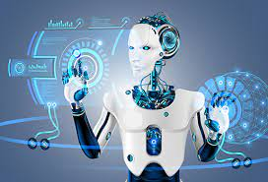

**MODULE CODE: ITLES801**

**MODULE TITLE: Embedded System Development**

**Class: B-Tech of IT**



**Group 6**

***MEMBERS:***

1. ***23RP00761***
2. ***23RP01617***
3. ***23RP01381***

**Homework 1**

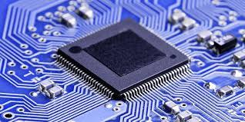 **A microcontroller (MCU)** is a single integrated circuit that is designed to control specific tasks within electronic systems. It combines the functions of a central processing unit (CPU), memory, and input/output interfaces, all on a single chip.

Q1 a)

**Microcontroller**

**The microcontroller used in Embedded System. for example:**  
• Security Systems  
• Laser Printers  
• Automation System  
• Robotics, etc.

**Types of Microcontroller**

**Types of microcontrollers**

Common MCUs include the Intel MCS-51, often referred to as an 8051 microcontroller, which was first developed in 1985; the AVR microcontroller developed by Atmel in 1996; the programmable interface controller (PIC) from Microchip Technology; and various licensed Advanced RISC Machines (ARM) microcontrollers.

A number of companies manufacture and sell microcontrollers, including NXP Semiconductors, Renesas Electronics, Silicon Labs and Texas Instruments.

**Other types**

a) **8-bit Microcontrollers:** typically used in simple applications such as toys, small appliances, and remote controls. They have a limited processing power and memory capacity, but they are easy to use and cost-effective.

**b) 16-bit Microcontrollers:**These are more advanced than 8-bit microcontrollers and are capable of performing more complex tasks. They are commonly used in applications such as medical devices, automotive systems, and industrial control systems.

**c) 32-bit Microcontrollers:**These are the most powerful and feature-rich microcontrollers, capable of handling large amounts of data and performing high-speed processing. They are used in applications such as gaming systems, multimedia devices, and high-end industrial automation.

**d) ARM Microcontrollers:** Is based on the ARM architecture and are widely used in a variety of applications, including mobile devices, automotive systems, and industrial control systems.

**e) PIC Microcontrollers:** These microcontrollers are manufactured by Microchip Technology and are commonly used in a wide range of applications, including home appliances, automotive systems, and medical devices.

**f) AVR Microcontrollers:** These microcontrollers are manufactured by Atmel Corporation and are commonly used in applications such as robotics, industrial control systems, and consumer electronics.

**g) FPGA-based Microcontrollers:** Used to provide highly customizable and flexible processing capabilities. Used in applications such as digital signal processing, video processing, and high-speed networking.

A microcontroller is a compact integrated circuit designed to govern a specific operation in an [embedded system](https://internetofthingsagenda.techtarget.com/definition/embedded-system). A typical microcontroller includes a processor, memory and input/output (I/O) peripherals on a single chip.

Sometimes referred to as an embedded controller or microcontroller unit (MCU), microcontrollers are found in vehicles, robots, office machines, medical devices, mobile radio transceivers, vending machines and home appliances, among other devices. They are essentially simple miniature personal computers (PCs) designed to control small features of a larger component, without a complex front-end operating system (OS).

**How do microcontrollers work?**

A microcontroller is embedded inside of a system to control a singular function in a device. It does this by interpreting data it receives from its I/O peripherals using its central processor. The temporary information that the microcontroller receives is stored in its data memory, where the processor accesses it and uses instructions stored in its program memory to decipher and apply the incoming data. It then uses its I/O peripherals to communicate and enact the appropriate action.

Microcontrollers are used in a wide array of systems and devices. Devices often utilize multiple microcontrollers that work together within the device to handle their respective tasks.

For example, a car might have many microcontrollers that control various individual systems within, such as the anti-lock braking system, traction control, fuel injection or suspension control. All the microcontrollers communicate with each other to inform the correct actions. Some might communicate with a more complex central computer within the car, and others might only communicate with other microcontrollers. They send and receive data using their I/O peripherals and process that data to perform their designated tasks.

**What are the elements of a microcontroller?**

1. **Processor Core:** This executes instructions and performs calculations.

2. **Memory:** Typically, microcontrollers have two main types of memory: **RAM** for temporary data storage and **ROM** or **flash memory** for storing the program or firmware.

3**. Peripherals:** These are additional integrated components that offer functionalities such as **input/output (I/O) ports, timers,** analog-to-digital converters **(ADCs**), serial communication interfaces **(UART, SPI, I2C**), **PWM** (Pulse Width Modulation), and more. These peripherals enable the microcontroller to interact with the external environment.

The core elements of a microcontroller are:

* The processor ([CPU](https://www.techtarget.com/whatis/definition/processor)) -- A processor can be thought of as the brain of the device. It processes and responds to various instructions that direct the microcontroller's function. This involves performing basic arithmetic, logic and I/O operations. It also performs data transfer operations, which communicate commands to other components in the larger embedded system.
* Memory -- A microcontroller's memory is used to store the data that the processor receives and uses to respond to instructions that it's been programmed to carry out. A microcontroller has two main memory types:
  1. Program memory, which stores long-term information about the instructions that the CPU carries out. Program memory is non-volatile memory, meaning it holds information over time without needing a power source.
  2. Data memory, which is required for temporary data storage while the instructions are being executed. Data memory is volatile, meaning the data it holds is temporary and is only maintained if the device is connected to a power source.
* I/O peripherals -- The input and output devices are the interface for the processor to the outside world. The input ports receive information and send it to the processor in the form of binary data. The processor receives that data and sends the necessary instructions to output devices that execute tasks external to the microcontroller.

While the processor, memory and I/O peripherals are the defining elements of the microprocessor, there are other elements that are frequently included. The term *I/O peripherals* itself simply refers to supporting components that interface with the memory and processor. There are many supporting components that can be classified as peripherals. Having some manifestation of an I/O peripheral is elemental to a microprocessor, because they are the mechanism through which the processor is applied.

Other supporting elements of a microcontroller include:

* Analog to Digital Converter (ADC) -- An ADC is a circuit that converts analog signals to digital signals. It allows the processor at the center of the microcontroller to interface with external analog devices, such as sensors.
* Digital to Analog Converter ([DAC](https://www.techtarget.com/whatis/definition/digital-to-analog-conversion-DAC)) -- A DAC performs the inverse function of an ADC and allows the processor at the center of the microcontroller to communicate its outgoing signals to external analog components.
* System bus -- The system bus is the connective wire that links all components of the microcontroller together.
* Serial port -- The serial port is one example of an I/O port that allows the microcontroller to connect to external components. It has a similar function to a USB or a parallel port but differs in the way it exchanges bits.

**Microcontroller features**

A microcontroller's processor will vary by application. Options range from the simple 4-bit, 8-bit or 16-bit processors to more complex 32-bit or 64-bit processors. Microcontrollers can use volatile memory types such as random access memory ([RAM](https://www.techtarget.com/searchstorage/definition/RAM-random-access-memory)) and non-volatile memory types -- this includes [flash memory](https://www.techtarget.com/searchstorage/definition/flash-memory), erasable programmable read-only memory (EPROM) and electrically erasable programmable read-only memory (EEPROM).

Generally, microcontrollers are designed to be readily usable without additional computing components because they are designed with sufficient onboard memory as well as offering pins for general I/O operations, so they can directly interface with sensors and other components.

Microcontroller architecture can be based on the Harvard architecture or von Neumann architecture, both offering different methods of exchanging data between theS processor and memory. With a Harvard architecture, the data bus and instruction are separate, allowing for simultaneous transfers. With a Von Neumann architecture, one bus is used for both data and instructions.

Microcontroller processors can be based on complex [instruction set](https://www.techtarget.com/whatis/definition/instruction-set) computing ([CISC](https://www.techtarget.com/whatis/definition/CISC-complex-instruction-set-computer-or-computing)) or reduced instruction set computing ([RISC](https://www.techtarget.com/whatis/definition/RISC)). CISC generally has around 80 instructions while RISC has about 30, as well as more addressing modes, 12-24 compared to RISC's 3-5. While CISC can be easier to implement and has more efficient memory use, it can have performance degradation due to the higher number of clock cycles needed to execute instructions. RISC, which places more emphasis on software, often provides better performance than CISC processors, which put more emphasis on hardware, due to its simplified instruction set and, therefore, increased design simplicity, but because of the emphasis it places on software, the software can be more complex. Which ISC is used varies depending on application.

When they first became available, microcontrollers solely used assembly language. Today, the [C programming language](https://www.techtarget.com/searchwindowsserver/definition/C) is a popular option. Other common microprocessor languages include Python and JavaScript.

**Microcontroller applications**

Microcontrollers are used in multiple industries and applications, including in the home and enterprise, building automation, manufacturing, robotics, automotive, lighting, smart energy, industrial automation, communications and internet of things ([IoT](https://internetofthingsagenda.techtarget.com/definition/Internet-of-Things-IoT)) deployments.

One very specific application of a microcontroller is its use as a digital signal processor. Frequently, incoming analog signals come with a certain level of noise. Noise in this context means ambiguous values that cannot be readily translated into standard digital values. A microcontroller can use its ADC and DAC to convert the incoming noisy analog signal into an even outgoing digital signal.

The simplest microcontrollers facilitate the operation of electromechanical systems found in everyday convenience items, such as ovens, refrigerators, toasters, mobile devices, [key fobs](https://www.techtarget.com/searchsecurity/definition/key-fob), video game systems, televisions and lawn-watering systems. They are also common in office machines such as photocopiers, scanners, fax machines and printers, as well as Smart meters, ATMs and security systems.

More sophisticated microcontrollers perform critical functions in aircraft, spacecraft, ocean-going vessels, vehicles, medical and life-support systems as well as in robots. In medical scenarios, microcontrollers can regulate the operations of an artificial heart, kidney or other organs. They can also be instrumental in the functioning of prosthetic devices.

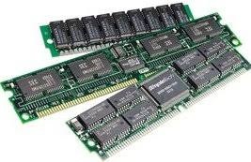 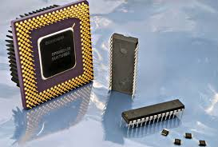

**ROM**

**RAM**

b) Memory

* **Memory:** refers to the electronic component used to store data temporarily or permanently. There are different types of memory within a microcontroller, each serving distinct purposes:
* **RAM (Random Access Memory):** RAM is volatile memory used for temporary data storage during program execution. It allows the microcontroller to read from and write to it, providing fast access to data. However, it loses its content when the power is turned off.
* **ROM (Read-Only Memory):** ROM stores data or instructions that are permanently written during the manufacturing process and cannot be altered by normal program execution. Some microcontrollers use flash memory, which is a type of re-writable ROM, allowing the stored data to be changed or updated.
* 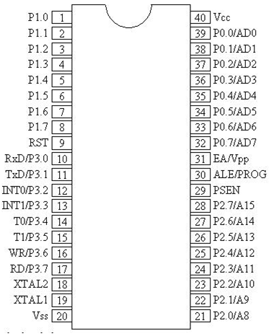 **Input/output (I/O) Ports:** These ports enable communication between the microcontroller and external devices, allowing it to receive input from sensors and send output to control various components like LEDs, motors, or displays. In embedded systems, I/O (Input/Output) ports are essential components that allow the microcontroller or microprocessor to interact with the external world, including sensors, actuators, and other devices. I/O ports are used to transfer data to and from the processor and the external environment. **I/O Ports** and their Functions. The four ports P0, P1, P2, and P3, each use 8 pins, making them 8-bit ports. Upon RESET, all the ports are configured as inputs, ready to be used as as input ports. When the first 0 is written to a port, it becomes an output.

**c) Input/output ports**

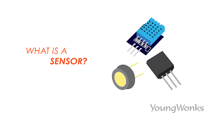 **Sensors:** Are devices that detect and respond to changes in the physical environment. **Sensors** are essential components of embedded systems that enable them to interact with the physical world..

d) Sensors

* They include **temperature sensors, motion sensors, light sensors,** and more, allowing the microcontroller to gather data from its surroundings. 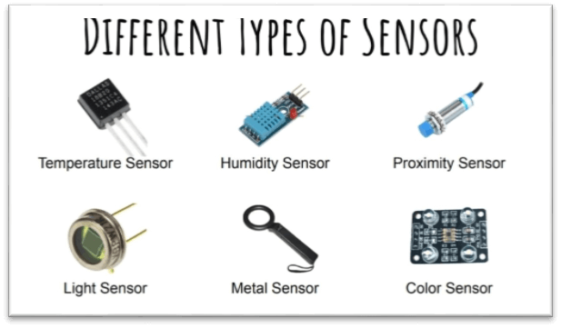

**Advantages of Sensors:**

* **Sensors** can computerize responsibilities and growing performance and accuracy.
* **Sensors** used to monitor situations and collect records in real-time, and knowledgeable choice-making.
* **Sensors** used to monitor and manipulate structures remotely, permitting operation and maintenance.
* **Sensors** used to enhance protection by detecting the presence of human beings or items in dangerous regions.
* **Sensors** used to preserve resources, adjust the construction temperature based totally on occupancy or turn off lighting while a room isn't in use.
* **Sensors** enhance the exceptional of merchandise and services, for instance, by tracking the exceptional of the air or water.
* **Disadvantages of Sensors:**
* **Sensors** may be expensive depends on their functions.
* **Sensors** can want to be covered from bodily harm.
* **Sensors** also require ordinary adjustment to make certain accuracy.
* **Sensors** might also have controlled ranges.
* **Sensors** may not be appropriate for all environments, as a few sensors may not be capable of facing up to excessive ranges of moisture or dust.
* **Sensors** also enhance privacy issues if they're used to collect non-public records, together with area or biometric information.

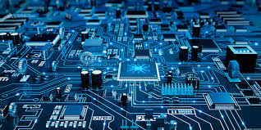

e) Electronic and Electromechanical components

* **Disadvantages of Sensors:**
* **Sensors may be expensive depends on their functions.**
* **Sensors can want to be covered from bodily harm.**
* **Sensors also require ordinary adjustment to make certain accuracy.**
* **Sensors might also have controlled ranges.**
* **Sensors may not be appropriate for all environments, as a few sensors may not be capable of facing up to excessive ranges of moisture or dust.**
* **Sensors also enhance privacy issues if they're used to collect non-public records, together with area or biometric information.**

**Electronic component** is a device in an electrical system that controls the flow of electrons in the circuit.

**Electronic** and **Electromechanical Components** Microcontrollers interact with various electronic components like transistors, resistors, and capacitors, as well as electromechanical components such as motors, relays, LEDs, etc., to perform specific tasks.

**Electronic** describes machines and devices that require electrical currents to run, and that use microchips and transistors to direct that current. cars, computers, radios, televisions, phones, etc.

* **Electronic Components and Their Function**
* **Capacitors**: Store electrical charge in an electrical field.
* **Diodes**: Components that conduct electricity in only one direction.
* **Integrated Circuits or ICs**: Merged into a chip or semiconductor; a whole system rather than a single component**.**
* **Magnetic or Inductive Components**: These are Electrical components that use magnetism.
* **Network Components**: Components that use more than 1 type of Passive Component.
* **Piezoelectric devices, crystals, resonators**: Passive components that use piezoelectric. effect.
* **Resistors**: Components used to resist current.
* **Semiconductors**: Electronic control components with no moving parts.
* **Switches**: Components that may be made to either conduct (closed) or not (open).
* **Terminals and Connectors**: Components to make electrical connection.
* **Transistors**: A semiconductor device capable of amplification**.**

**Electronic and Electromechanical components some symbols and their names**

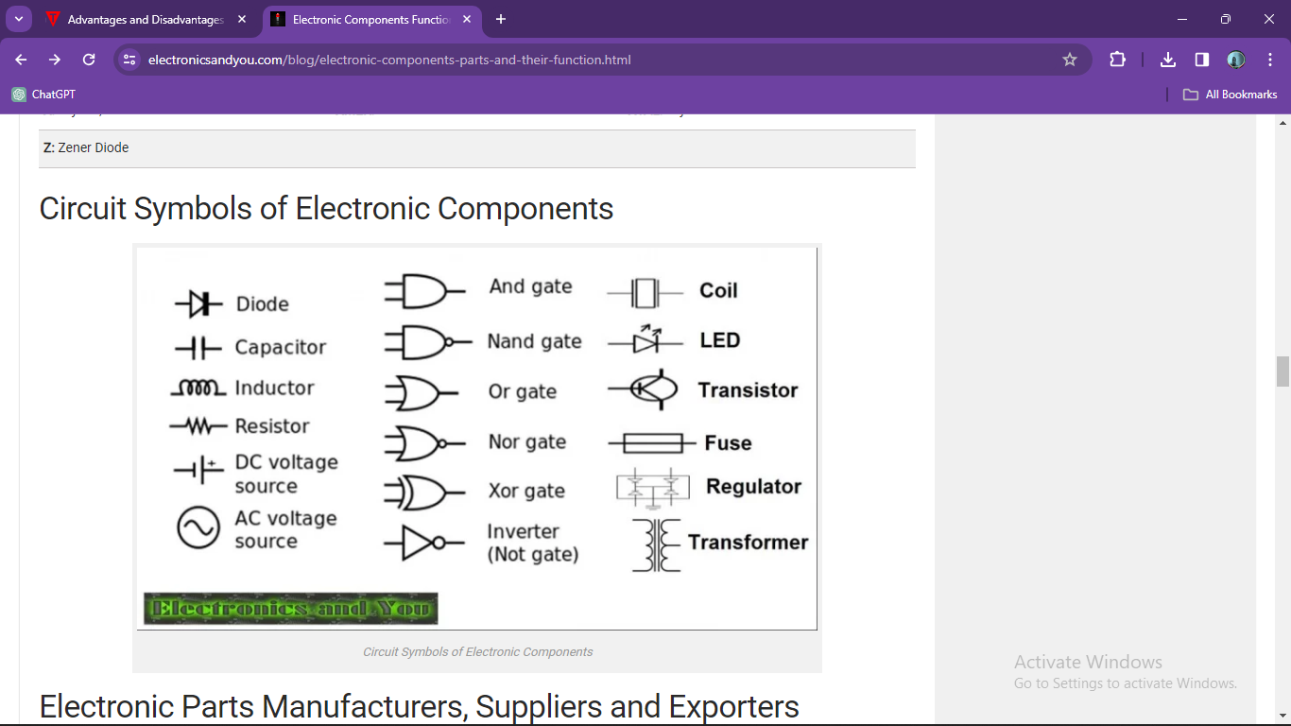

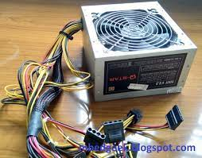 An embedded system power supply has to provide voltages at all these levels across the entire system.

f) **Power Supply**

Power supplies for embedded systems normally must provide the primary input power at a standard voltage, and the power regulation strategy on the PCB provides power at the particular core voltages.

Power supply unit is a critical component of modern computer systems. It supplies the required voltage to all elements using appropriate converters, cables and connectors.

The main purpose of the power supply is to protect the contents of a computer system from various external threats, voltage surges, errors, etc.

* **Three types of power supply?**

### **Linear Power Supply**

Linear power supplies are widely used when precise regulation and noise elimination are paramount. Although not the most efficient power source, they offer the finest performance in terms of stability and reliability. Linear power supplies derive their name from the fact that they do not use a switch to regulate voltage output.

These power supplies have been used for years, known for their overall [reliability and relatively noise-free operation](https://www.swartzengineering.com/High-Voltage-Power-Supply-Grounding). However, they have some drawbacks, such as more significant components leading to increased size, more excellent heat dissipation, and lower efficiency than switched power supplies and batteries, sometimes reaching only 50% efficiency.

### **Switched Power Supply**

Switched mode power supplies (SMPS) are more complex in design but offer greater versatility in polarity and higher efficiency, sometimes exceeding 80%. Despite having more components, their smaller size and lower cost make them an attractive alternative to linear power supplies. One advantage of switched-mode power supplies is the reduced loss across the switch due to their higher operating frequencies.

However, SMPS can radiate noise and interfere with other circuits, necessitating interference suppression measures like shielding and adherence to layout protocols. The main benefits of a [switched power supply](https://www.swartzengineering.com/blog/what-high-voltage-power-distribution) include its small size, lightweight design, wide input voltage range, and high output range. On the downside, SMPS has complex circuitry, can pollute the AC mains, operates at high frequencies requiring interference mitigation, and is generally noisier than linear power supplies.

### **Battery-Based Power Supply**

Battery-based power supplies are mobile energy storage units that produce negligible noise, [ensuring minimal interference](https://www.swartzengineering.com/Selecting-The-Best-AC-DC-Power-Supply-For-Peak-Load-Applications) with electronic devices. However, they lose capacity over time and do not provide constant voltage as the batteries drain. In most laser diodes applications, batteries are considered the least efficient method of powering equipment. Matching the correct voltage to the load can be challenging, and using a battery that exceeds the driver's or controller's internal power dissipation may cause damage.

Next, we will consider the main parameters and characteristics on which the performance of the power supply depends:

* Power – determines the possibility of supplying energy to all components of the system;
* Efficiency – shows the efficiency of the power supply in converting electrical energy;
* Supply line current – shows the energy volume that can be transmitted along each line;
* Input voltage – indicates the power source being used;
* Type of connectors and their number – provide connection to system devices.

It is also worth noting the importance of the unit’s form factor, its design, and the cooling used.

g) Communication interfaces (UART, SPI, I2C, Wi-Fi, Bluetooth, RF)

**UART (Universal Asynchronous Receiver/Transmitter):** Used for serial communication between the microcontroller and other devices. It facilitates the transmission and reception of data between two devices without the need for a clock signal to synchronize the communication process.

**SPI (Serial Peripheral Interface):** Allows synchronous serial communication between the microcontroller and peripheral devices. used primarily in embedded systems for short-distance wired communication between integrated circuits.

**I2C (Inter-Integrated Circuit):** A serial communication protocol connecting multiple components that share the same bus lines. is a very cheap, yet effective, network used to interconnect peripheral devices within small-scale embedded systems. It is sometimes also known as IIC

**Wi-Fi (Wireless Fidelity):** Enabling microcontrollers to communicate wirelessly with other devices or networks, facilitating IoT applications and data transfer. Is good choice for IoT applications that need to transfer data to the cloud.

**Bluetooth** is a wireless technology that enables a wireless device to communicate in the 2.4 GHz industrial, scientific and medical (ISM) band. It has been specifically designed as a low cost, low power radio technology, which is particularly suited for the short range personal area network (PAN) application.

**An RF module** (short for radio-frequency module) is a (usually) small electronic device used to transmit and/or receive radio signals between two devices. In an embedded system it is often desirable to communicate with another device wirelessly.

**Common advantages of above components**

**Simplicity:** easy to implement, requiring minimal hardware overhead.

**Flexibility:**allows for versatile system designs, accommodating a wide range of applications.

**Wide Adoption:**are widespread popularity, support and compatible devices available in the market.

**Common disadvantages of above components**

**Limited Distance:** most of all designed for short-distance (few meters).

**Availability issues:** Many components are not easilyfound by the customers